CS460-580 Project # 3 Fall 2021

Group Project

|  |  |
| --- | --- |
| Student Names | Antonio Zea Jr |
| Section | (Student groups can be made up from students from either section) |

1. Revise your EER diagram from Project 1 problem #1 (the art museum) so for your group you have a single diagram you are submitting. For all relationships be sure to consider your minimum participation constraints and explain your assumptions here. Reminder the narrative is from page 276 example 8.20 of the 6th edition textbook and also posted with this Blackboard assignment.
2. Convert/revise your EER schema into database relations for your final EER diagram in part 1.
3. Use DBMS software of your choice (Microsoft Access is installed on all machines in the classroom and in the lab, but you are welcome to use MySQL etc. but would need to set it up on your own). Create database Museum, and populate tables with data of your choice that will return records for each query below. (Each table must have at least seven rows.) Include here the SQL DDL for creating your schema from part 1. **Be sure to specify all primary key, foreign key, uniqueness, and non-nullity constraints.**
4. Write SQL queries for the following questions:
   1. For all paintings displayed on exhibition named "Morning mist", retrieve painting title, year created, material the painting was drawn on, artist name, and his/hers country of origin. Must use IN operator.
   2. For all oil or watercolor paintings by Monet retrieve painting style, material, title, and year when it was created. Must use EXISTS operator.
   3. For sculptures display: material, the number of sculptures made of that material, and min and max weight of sculptures made of that material.
   4. Retrieve the number (count) of art objects that are borrowed from Barnes collection.

SUBMIT:

One word document called P3-LastNamesOfbothPartners.

In the document include names of students in the group, section (either 580 or 460) date you submitted and provide the following:

1) EER diagram created in a diagraming tool.

2) Convert EER diagram to produce DB relations schema. Underline PK with straight line. Use Italic for foreign keys and draw arrow to the referenced primary key.

3) The following:

1. SQL DDL to create your schema as described above
2. Screenshot of each populated table created in DBMS software of your choice.
3. For each query put the English query description (copied from above) followed by the query in standard SQL from the same DBMS.
4. Include a screenshot of the resulting output of the query from the same DBMS.

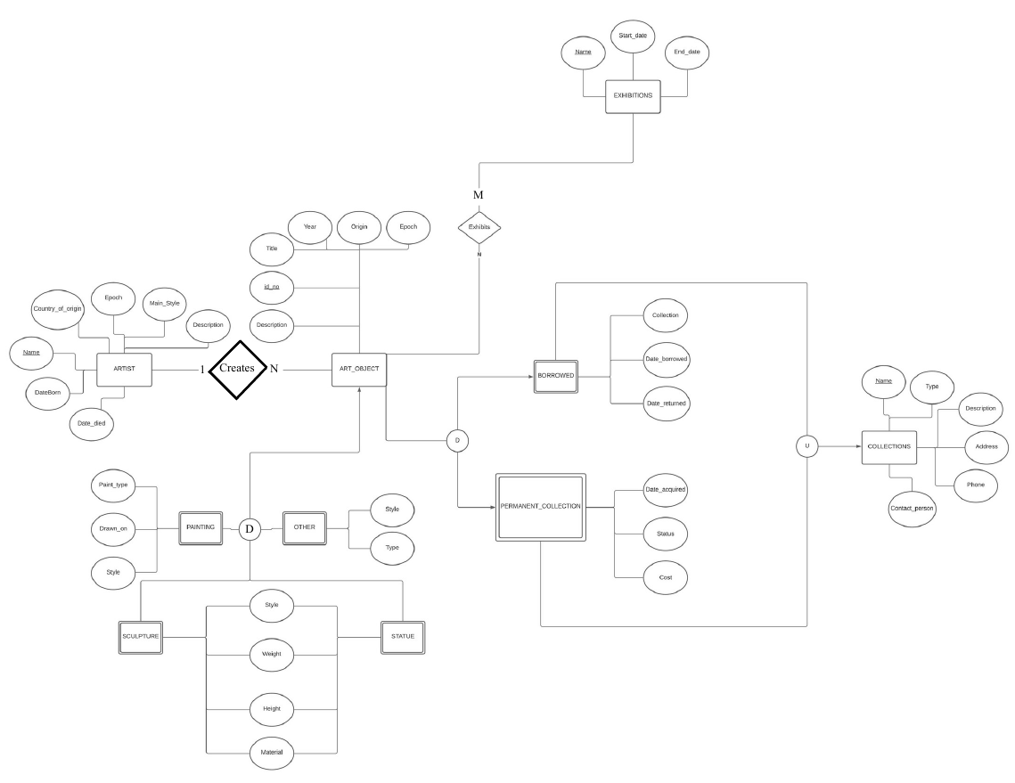

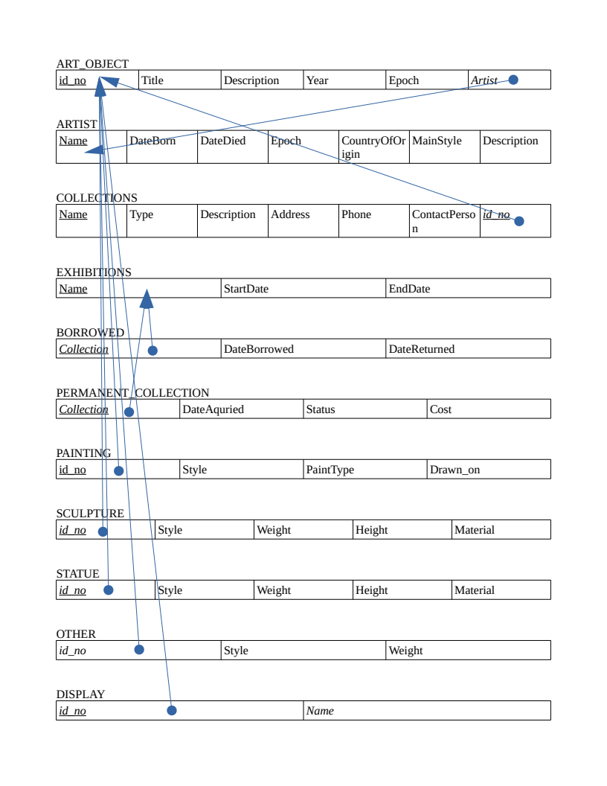

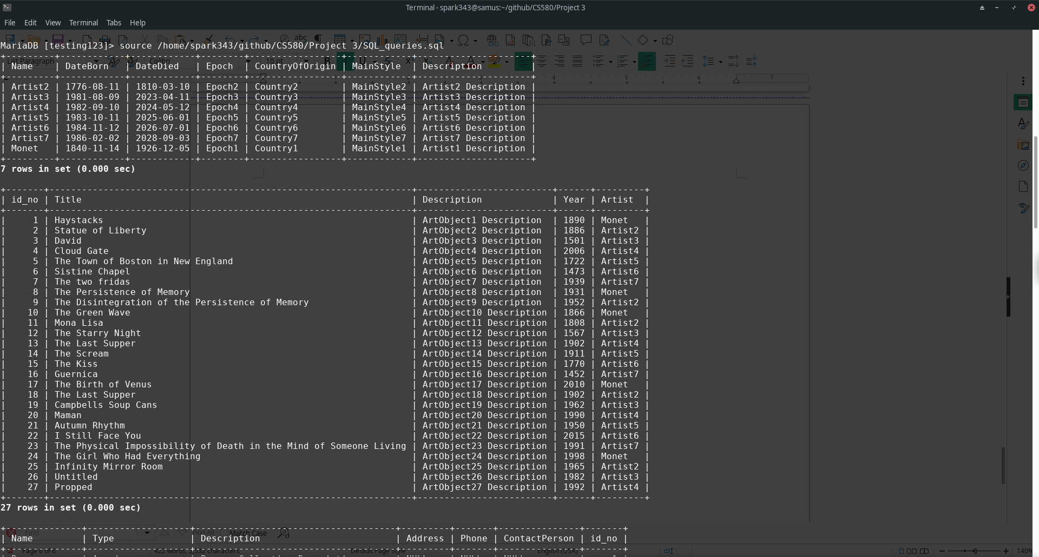

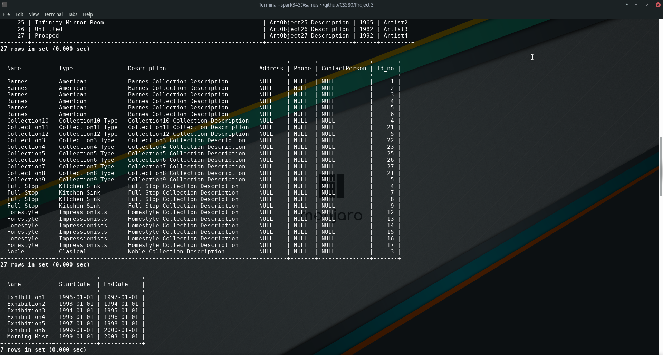



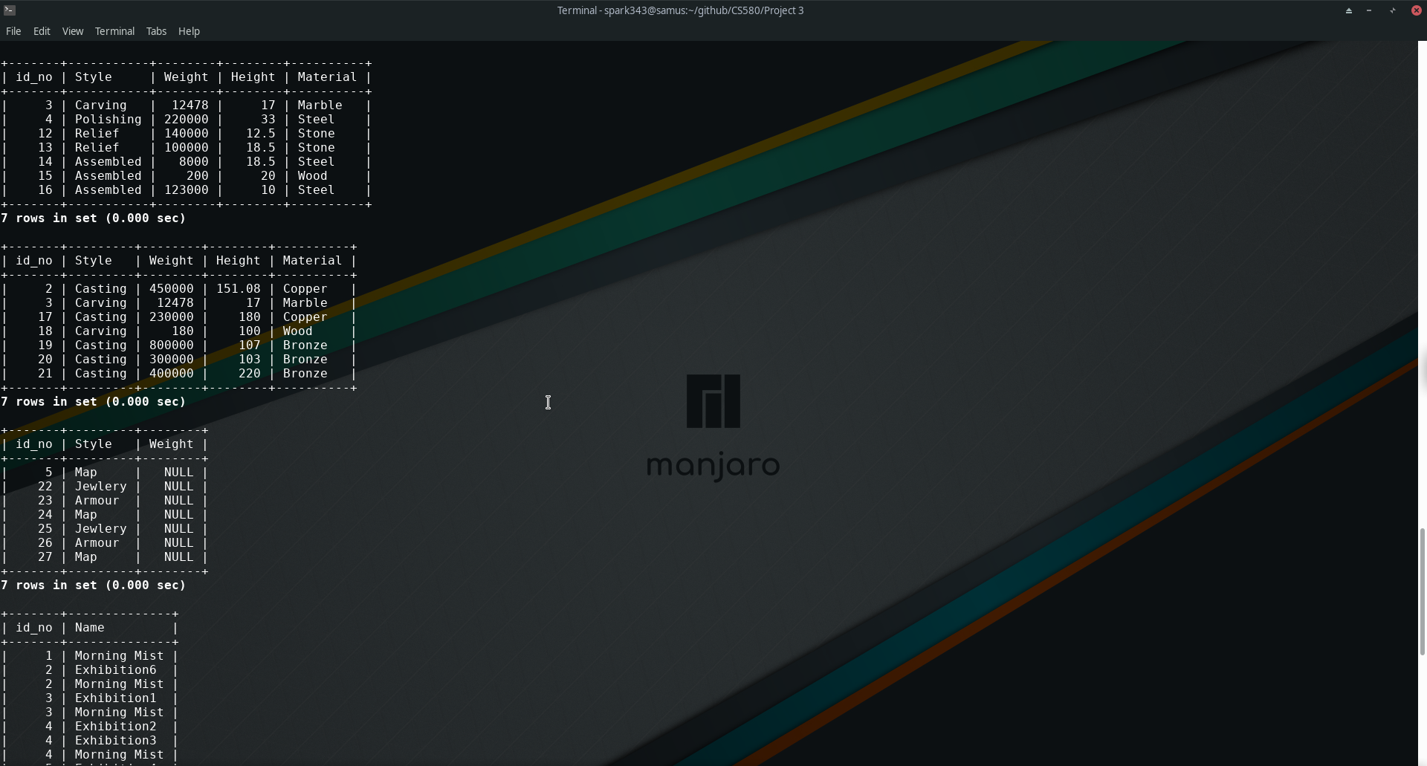

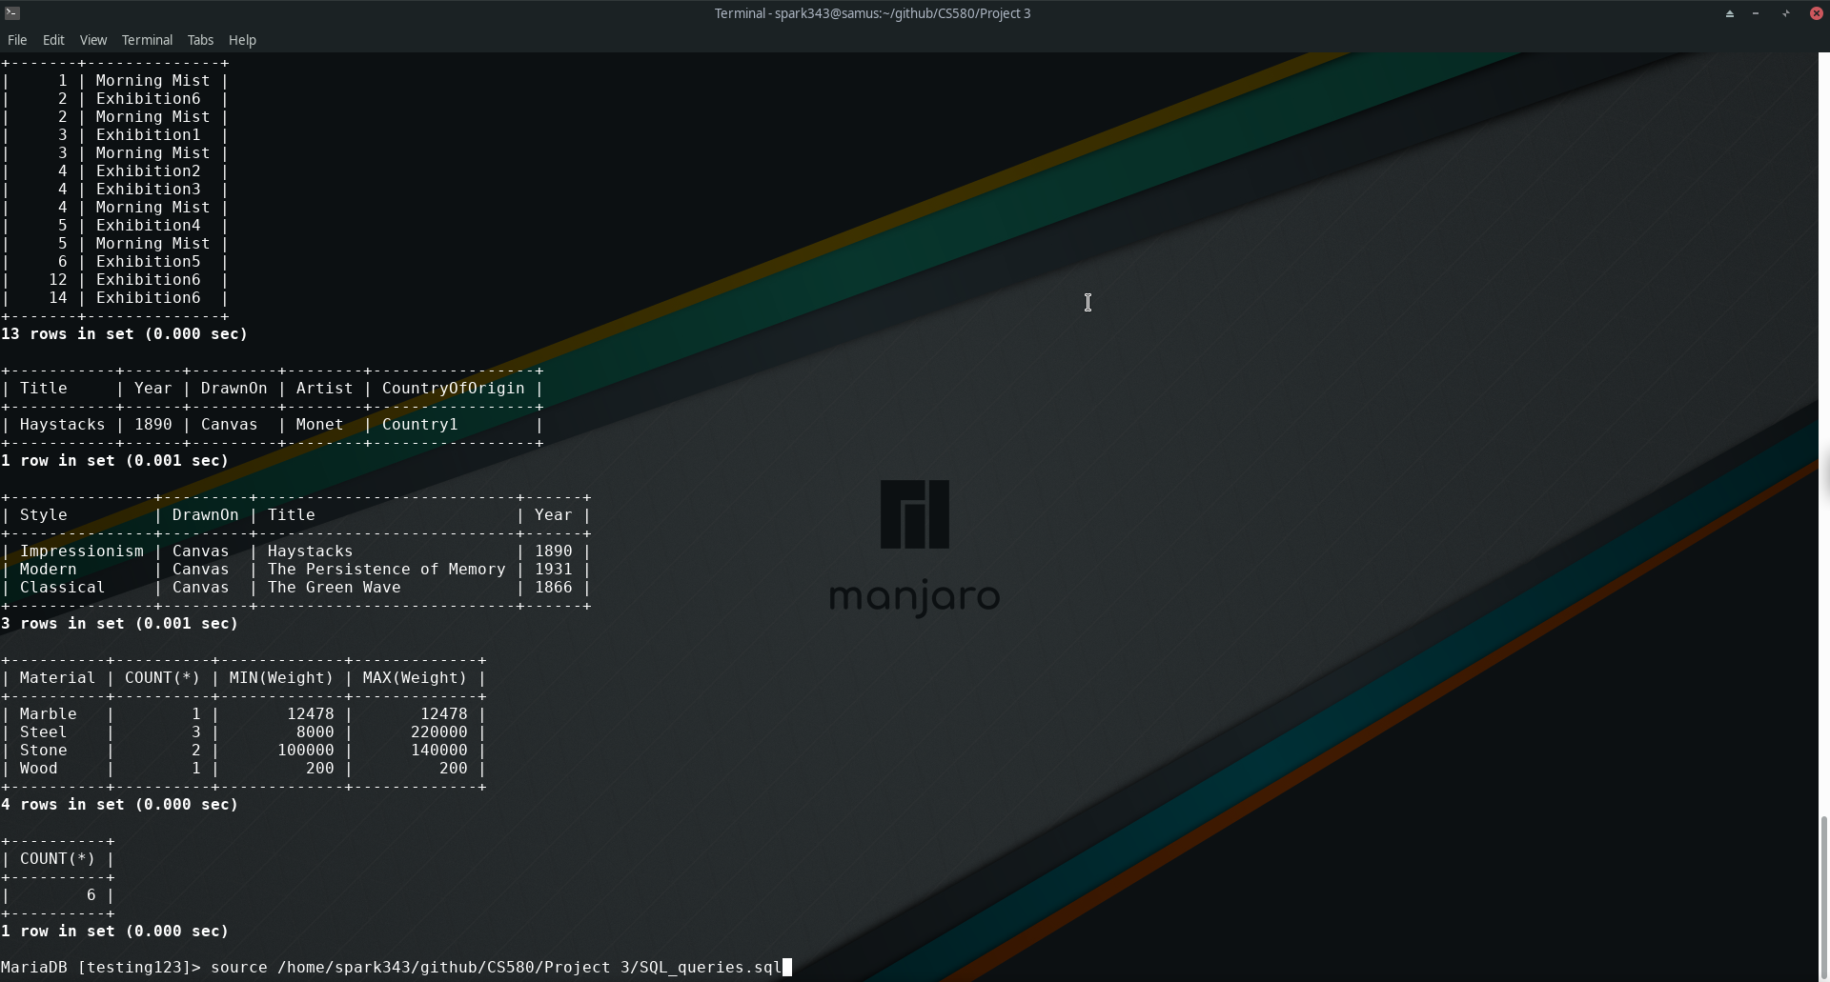

For all paintings displayed on exhibition named "Morning mist",

retrieve painting title, year created, material the painting

was drawn on, artist name, and his/hers country of origin.

Must use IN operator.

FROM DISPLAYS;

select ao.Title,

ao.Year,

pa.DrawnOn,

ao.Artist,

a.CountryOfOrigin

FROM (

(

(

ART_OBJECT ao

join ARTIST a ON ao.Artist = a.Name

)

join PAINTING pa ON ao.id_no = pa.id_no

)

join DISPLAYS d ON ao.id_no = d.id_no

)

join EXHIBITIONS ex ON d.Name = ex.Name

WHERE ex.Name IN ('Morning Mist');

+-----------+------+---------+--------+-----------------+

| Title | Year | DrawnOn | Artist | CountryOfOrigin |

+-----------+------+---------+--------+-----------------+

| Haystacks | 1890 | Canvas | Monet | Country1 |

+-----------+------+---------+--------+-----------------+

1 row in set (0.001 sec)

For all oil or watercolor paintings by Monet retrieve painting style,

material, title, and year when it was created. Must use EXISTS operator.

SELECT p.Style,

p.DrawnOn,

ao.Title,

ao.Year

FROM (

ART_OBJECT ao

join ARTIST a ON ao.Artist = a.Name

)

join PAINTING p ON ao.id_no = p.id_no

WHERE a.Name = 'Monet'

AND EXISTS (

SELECT *

WHERE p.PaintType = 'oil'

OR p.PaintType = 'watercolor'

);

+---------------+---------+---------------------------+------+

| Style | DrawnOn | Title | Year |

+---------------+---------+---------------------------+------+

| Impressionism | Canvas | Haystacks | 1890 |

| Modern | Canvas | The Persistence of Memory | 1931 |

| Classical | Canvas | The Green Wave | 1866 |

+---------------+---------+---------------------------+------+

3 rows in set (0.001 sec)

For sculptures display: material, the number of sculptures

made of that material, and min and max weight of sculptures made

of that material.

SELECT Material,

COUNT(*),

MIN(Weight),

MAX(Weight)

FROM SCULPTURE

GROUP BY(Material);

+----------+----------+-------------+-------------+

| Material | COUNT(*) | MIN(Weight) | MAX(Weight) |

+----------+----------+-------------+-------------+

| Marble | 1 | 12478 | 12478 |

| Steel | 3 | 8000 | 220000 |

| Stone | 2 | 100000 | 140000 |

| Wood | 1 | 200 | 200 |

+----------+----------+-------------+-------------+

4 rows in set (0.000 sec)

Retrieve the number (count) of art objects that are borrowed

from Barnes collection.

SELECT COUNT(*)

FROM (

COLLECTIONS c

join BORROWED b ON c.Name = b.Collection

)

join ART_OBJECT ao ON c.id_no = ao.id_no

WHERE c.Name = 'Barnes';

+----------+

| COUNT(*) |

+----------+

| 6 |

+----------+

1 row in set (0.000 sec)